**Python Class**

* A class defines a set of attributes and methods that the created objects (instances) can have.
* **Creating a Class**

**class** **Dog**:

species = "Canine" *# Class attribute*

**def** __init__(self, name, age):

self.name = name *# Instance attribute*

self.age = age *# Instance attribute*

**Python Objects**

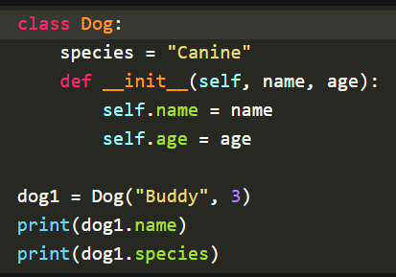

**Self Parameter**

* Reference to the current instance of the class.It allows us to access the attributes and methods of the object.

**__init__ Method**

* Constructor in Python, automatically called when a new object is created. It initializes the attributes of the class.
* **NOTE:**constructor is a special method used in object-oriented programming to initialize objects

**Class and Instance Variables**

* **Class Variables** are the variables that are shared across all instances of a class. It is defined at the class level.
* **Instance Variables** are thevariables that are unique to each instance (object) of a class.

**Python Inheritance**

Inheritance allows a class (child class) to acquire properties and methods of another class (parent class). It supports hierarchical classification and promotes code reuse.

**Types of Inheritance:**

1. **Single Inheritance:** A child class inherits from a single parent class.
2. **Multiple Inheritance:**A child class inherits from more than one parent class.
3. **Multilevel Inheritance:** A child class inherits from a parent class, which in turn inherits from another class.
4. **Hierarchical Inheritance:** Multiple child classes inherit from a single parent class.
5. **Hybrid Inheritance:** A combination of two or more types of inheritance.